<https://www.udemy.com/course/the-complete-web-development-bootcamp/learn/lecture/12374106#questions/12105158>

Adding JS to websites -

3 ways to inject css in to DOM, in line internal or from an external file.

JS is similar – can add JS in line via attribute in the HTML tag – poor choice for all the reasons css is, internal css tag and external file

Placement of script tag matters. The page needs to load then the script, so it goes at the end.

This is also good because JS may take a bit to run an could delay the page load

Can put it in the head use defer

Interactive web side respond to user actions

HTML Tree visualizer vs console .log of document

Traversing the DOM from the document

innerHTML is the space between the html tags

.click() simulates a mouse click

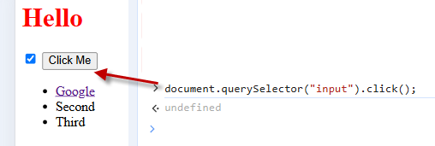

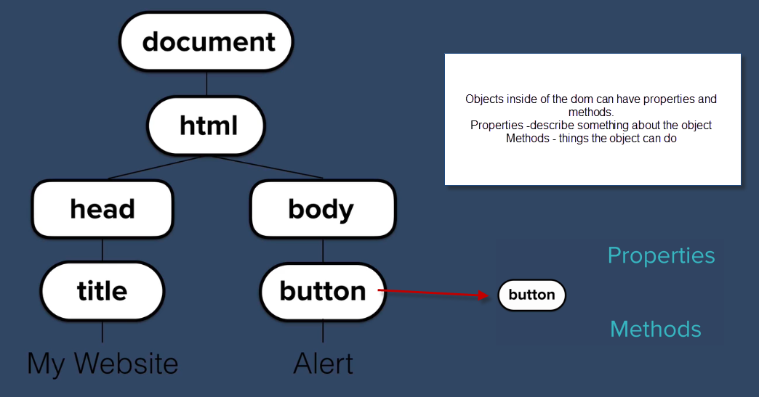

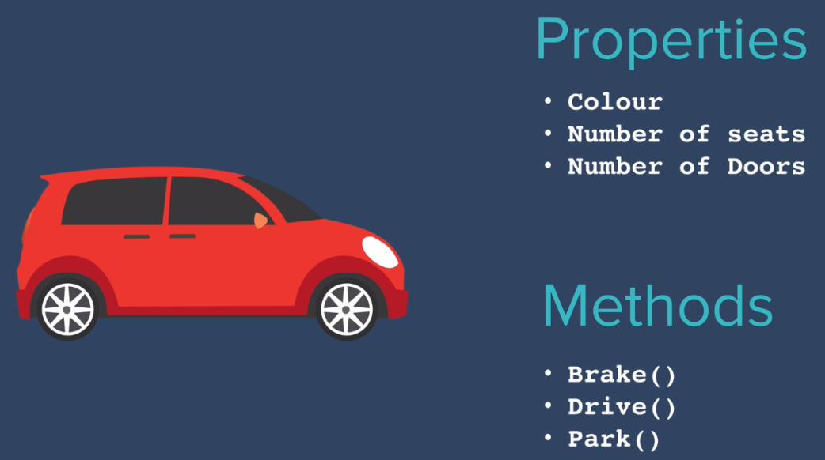

Can get a property

Can set a property using = sign

Call a method

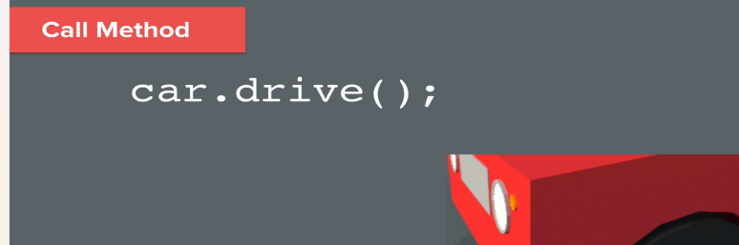

A method is something an object can do, it must be associated with an object a function is a set of instructions that perform a task, does not have to be associated with an object. A blue background with white text

Selecting with javascipt

.getElementsByTagName – returns an array of elements (its really an HTML Collection )

.getElementsByClassName – returns an array (its really an HTML Collection)

.querySelectorAll() – returns a node list -will see querySelector and querySelectorAll more in use across the web.

**1. .getElementsByClassName()**

* **Returns:** **Live** HTMLCollection
* **Use Case:** When you want to select elements by class name and need a **live** collection that updates if the DOM changes.
* **Limitations:** Does not support forEach() directly; must be converted to an array using Array.from() or [...collection].

**2. .querySelectorAll()**

* **Returns:** **Static** NodeList
* **Use Case:** When you need a **snapshot** of elements matching a CSS selector, and you don’t need it to update dynamically as the DOM changes.
* **Advantages:** Supports forEach() natively, making it easier to iterate over elements.

Hierarchical selectors have a space -can say get the a inside the li .querySelector(“li a”)

Combine selectors combining no space .querySelector(“li.item”)

<https://developer.mozilla.org/en-US/docs/Web/CSS/CSS_selectors/Selector_structure>

List of the HTML style object properties

<https://www.w3schools.com/jsref/dom_obj_style.asp>

using them in js

<https://dev.to/neutrino2211/using-css-selectors-in-javascript-3hlm>

property names camel case , values need to go in as strings even if numbers

Keep in mind Separation of concerns – structure vs style , in general but on the fly

HTML – content

CSS - Style

JS – behavior

.class.list.add in JS can add a class via js and the css in the css file can be applied or with .class.list.remove to remove there is also class.list.toggle

Text content property vs inner html text content would just return the text

Can also manipulate the attributes – class, href ect.

Use get vs set

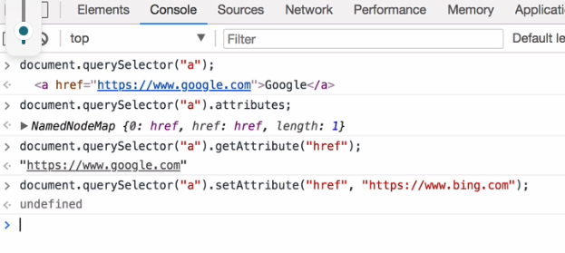

<https://www.udemy.com/course/the-complete-web-development-bootcamp/learn/lecture/12383818#questions/12105158>